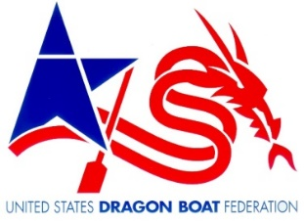

The mission of the USDBF is “to promote the growth and development of dragon boating in the U.S. for fitness, recreation, and team building at all levels of competition.”

USDBF Corona Virus Statement
We are all aware of the potential danger that the Corona Virus poses to ourselves, our families, our friends, our communities and the economy of our country. It is time for the U.S. dragon boating community to join with the other sports leagues around the country and the world to shut our activities down and contribute to the efforts to stop the spread of this deadly virus.
The United States center for Disease Control (CDC) has recommended that all gatherings of more than 50 people be suspended for the next eight weeks. To support this effort, USDBF is asking all teams and race organizers suspend practices, festivals and races in compliance with that recommendation. Teams and race organizers should monitor all federal, state and local guidelines for any changes in restrictions or conditions and adhere to the current recommendations.

